**Peter Califano**

**Brewery Expansion Model**

**Background:**

A local brewery currently produces 1000 barrels (bbl) of beer per year. Sales streams are divided into two categories: Draft (or On site) and Wholesale. On site sales typically yield 200 pints of beer for every BBL, selling at $6. Wholesale kegs sell at $225 per 1/2bbl keg. Both have a cost of 300/bbl. Operating expenses are currently 30% of total sales.

**Scenario 1:** The owners are concerned about the unpredictability of the market, in this scenario they would retain their current production capacity of 1000bbl per year and prioritize on site sales over wholesale, as the margins are higher.

**Scenario 2:** The brewery is considering an expansion to the production capacity of the brewery this year that would cost $100,000 and increase yearly production to 2000BBl. This would reduce cost/bbl for on site and wholesale from $300/bbl to $250/bbl. Additionally operating expenses would now account for 25% of sales as the owners believe that efficiencies of scale will reduce relative operating costs. The owners of the brewery would want to pass on these savings to the customer, reducing the sale price of on site $5 and lower the wholesale price of a 1/2bbl keg to $212.5. They hope that the increased production capacity and reduced costs for kegs will allow them to function as a production brewery, making a higher profit off of wholesale keg sales.

**Model**

**Demand**

Due to an unpredictable local market, projections for demand are unclear for the next year, but you are confident that demand for all three sales streams will increase 5% each year for the next five years. The table below shows expected minimum and maximum demand for the current year.



By using =Min+ (Max-Min)*RAND(), we can establish a random variable for the demand of each sales stream. We also calculate that after the initial demand set, each year demand increases by 5% for each revenue stream.

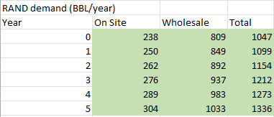

Example RAND demand table above.

**Profit Margins:**

Using the information provided we can calculate the net profit for each revenue stream. For on site sales, prices are set by the pint. The owners estimate that accounting for packaging and serving loss, each 1/2bbl of beer produces 100 pints of beer. We can then calculate dollar sales per BBL and subtract cost/BBL and operating expense to reach net profits for each revenue stream.

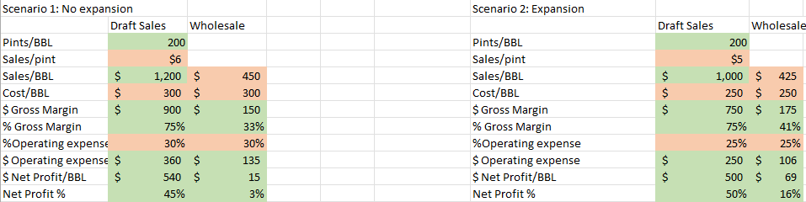

The most notable difference between the two scenarios is that the reduced cost/BBL and overall lower *relative* operating costs produce higher profit margins for all three streams of revenue despite lowering prices. Most importantly, this brings the net profit for wholesale kegs from 3% to 16%, now making them a more viable money maker.

**NPV**

With the net profit% we can now match the yearly demand to the profit of each revenue stream. In the tables below, you can see that net profit is calculated by multiplying demand times the $Net Profit/bbl and each revenue stream is added for the net profit for that year. From there we can calculate NPV for each scenario. In this instance, Scenario 1 proves to be more profitable.

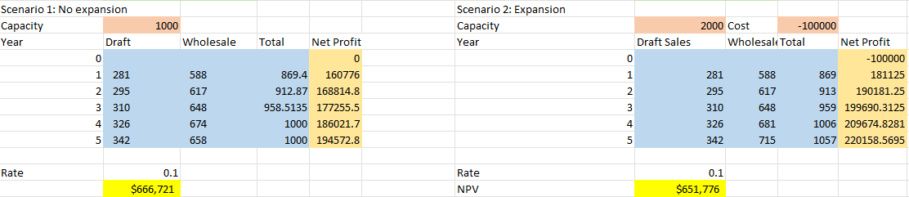

**Sensitivity Analysis**

We can perform sensitivity analysis by taking the difference between the scenario 1 and scenario 2 NPV calculations, then using the What If data table function to examine the effect of Draft and Wholesale demand on the outcome. This is shown in the table below. Cells that are positive (Highlighted in blue) indicate that Scenario 1’s NPV is greater than Scenario 2, while a cell with a negative number (highlighted in orange) indicates the opposite.

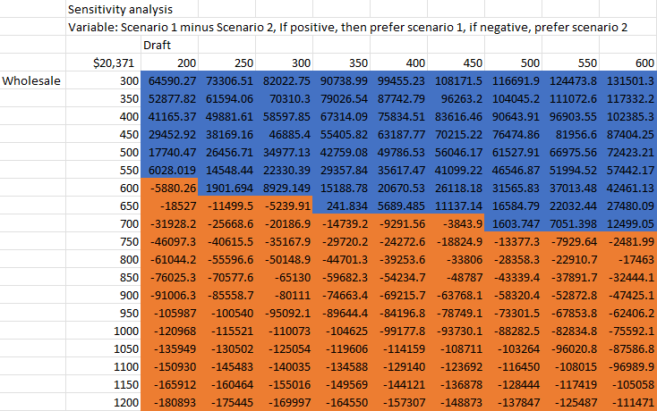

From the table we can determine that if initial wholesale demand is 550bbl/year or less, then the expansion is not viable as increased wholesale demand and margins are an integral part of the business strategy of scenario 2. We can also see that increased initial draft demand makes scenario 1 more viable until initial wholesale demand reaches 700bbl, at which point the expansion is always preferable. So, for example, if you are confident that initial wholesale demand is less than 550bbl, then you can be confident in not expanding capacity, and if wholesale demand is over 700bbl, you can be confident that the expansion will produce a higher NPV.

**Monte Carlo Simulation**

Using the Monte Carlo Simulation, we are able to see the effect of the randomized demand on the NPV of both projects. By running the model 1000 times, we are able to calculate the average NPV’s and the probability that each scenario is greater than the other. This is shown in the table below. This will give us more confidence in our decision between the two Scenarios

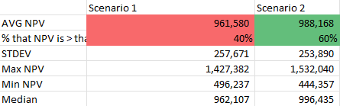

According to this table, the average NPV of Scenario 1 is 961,580 while the average NPV of Scenario 2 is 988,168. We also see that the Min NPV for Scenario 1 is ~50k higher than for Scnario 2, while the Max NPV for Scenario 2 is over 100k higher than Scenario 1.

*The probability that the NPV of Scenario 2 is more than Scenario 1 is approximately 60%*.

*With this we can determine that* ***Scenario 2 is more likely to produce a higher profit and is the preferred choice for the brewery****. Additionally, Scenario 2 is preferable as it allows the brewery to capitalize on further growth while reducing costs and operating expenses.* It may be worth mentioning that an extremely risk-averse owner may prefer plan 1 if they believe that demand will be very low, however this does not change our recommendation.

**Sources:**

*Note: Model was produced using both information from the sources below, as well as my own experience working at a local brewery that recently expanded its production.*

<https://craftbreweryfinance.com/breaking-down-the-taproom-focused-brewery-model/>

https://docs.google.com/document/d/1N4-VVKofaroikhG2ci7Mbz8Rcf3Lmfkz3No8dsYm6fs/edit?usp=share_link